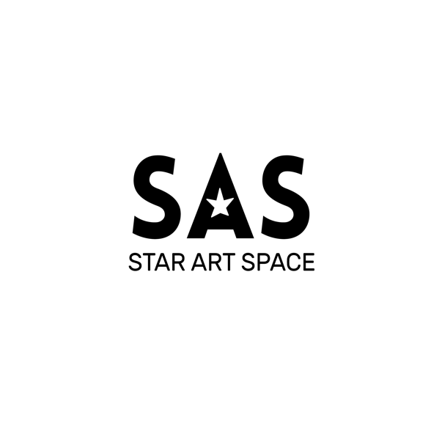

**SAS RESIDENCY APPLICATION:**

SAS (Star Art Space) is the special art project of “Chicken Star” art-café devoted to promotion of art and both local and foreign artists in Kyrgyzstan.

SAS welcomes all artists to apply, be it a famous artist, beginner, expat stopped in Bishkek for a month, or a person without any art education background.

The most important is VIBES coming from the artists works. The more unique, the better!

**What is SAS?**

* SAS is a program for artists to create their new works in the chill and creative atmosphere of Chicken Star and showcase their works in Chicken Star for a month

**SAS welcomes all genres of art including:**

**A**

► [Albanian art genres](https://en.wikipedia.org/wiki/Category:Albanian_art_genres)‎

► [Analytical art](https://en.wikipedia.org/wiki/Category:Analytical_art)‎

► [Art games](https://en.wikipedia.org/wiki/Category:Art_games)‎

► [Avant-garde art](https://en.wikipedia.org/wiki/Category:Avant-garde_art)‎

**B**

► [BioArt](https://en.wikipedia.org/wiki/Category:BioArt)‎

► [Botanical art](https://en.wikipedia.org/wiki/Category:Botanical_art)‎

► [Butoh](https://en.wikipedia.org/wiki/Category:Butoh)‎

**C**

► [Cartooning](https://en.wikipedia.org/wiki/Category:Cartooning)‎

► [Children's art](https://en.wikipedia.org/wiki/Category:Children%27s_art)‎

► [Cityscape art](https://en.wikipedia.org/wiki/Category:Cityscape_art)‎

► [Conceptual art](https://en.wikipedia.org/wiki/Category:Conceptual_art)‎

**D**

► [Dada](https://en.wikipedia.org/wiki/Category:Dada)‎

► [Decorative arts](https://en.wikipedia.org/wiki/Category:Decorative_arts)‎

► [Digital art](https://en.wikipedia.org/wiki/Category:Digital_art)‎

**E**

► [Environmental art](https://en.wikipedia.org/wiki/Category:Environmental_art)‎

**F**

► [Fantastic art](https://en.wikipedia.org/wiki/Category:Fantastic_art)‎

► [Fantastic realism](https://en.wikipedia.org/wiki/Category:Fantastic_realism)‎

► [Fantasy art](https://en.wikipedia.org/wiki/Category:Fantasy_art)‎

► [Figurative art](https://en.wikipedia.org/wiki/Category:Figurative_art)‎

► [Fin de siècle](https://en.wikipedia.org/wiki/Category:Fin_de_si%C3%A8cle)‎

► [Folk art](https://en.wikipedia.org/wiki/Category:Folk_art)‎

► [Found object](https://en.wikipedia.org/wiki/Category:Found_object)‎

**G**

► [Genres of Indian art](https://en.wikipedia.org/wiki/Category:Genres_of_Indian_art)‎

► [Glass art](https://en.wikipedia.org/wiki/Category:Glass_art)‎

► [Grotesque](https://en.wikipedia.org/wiki/Category:Grotesque)‎

**H**

► [Hardstone carving](https://en.wikipedia.org/wiki/Category:Hardstone_carving)‎

► [History paintings](https://en.wikipedia.org/wiki/Category:History_paintings)‎

**I**

► [Installation art](https://en.wikipedia.org/wiki/Category:Installation_art)‎

► [Interactive art](https://en.wikipedia.org/wiki/Category:Interactive_art)‎

► [Italian art genres](https://en.wikipedia.org/wiki/Category:Italian_art_genres)

**K**

► [Kaiju](https://en.wikipedia.org/wiki/Category:Kaiju)‎

**L**

► [Land art](https://en.wikipedia.org/wiki/Category:Land_art)‎

► [Landscape art](https://en.wikipedia.org/wiki/Category:Landscape_art)‎

**M**

► [Magic realism](https://en.wikipedia.org/wiki/Category:Magic_realism)‎

► [Military art](https://en.wikipedia.org/wiki/Category:Military_art)‎

► [Miniature painting](https://en.wikipedia.org/wiki/Category:Miniature_painting)‎

**N**

► [Naïve art](https://en.wikipedia.org/wiki/Category:Na%C3%AFve_art)‎

► [Neo-Dada](https://en.wikipedia.org/wiki/Category:Neo-Dada)‎

► [New media art](https://en.wikipedia.org/wiki/Category:New_media_art)‎

**O**

► [Outsider art](https://en.wikipedia.org/wiki/Category:Outsider_art)

**P**

► [Paleoart](https://en.wikipedia.org/wiki/Category:Paleoart)‎

Photography Art

► [Photography by genre](https://en.wikipedia.org/wiki/Category:Photography_by_genre)‎

► [Political art](https://en.wikipedia.org/wiki/Category:Political_art)‎

► [Portrait art](https://en.wikipedia.org/wiki/Category:Portrait_art)‎

► [Propaganda art](https://en.wikipedia.org/wiki/Category:Propaganda_art)‎

► [Psychedelic art](https://en.wikipedia.org/wiki/Category:Psychedelic_art)‎

► [Public art](https://en.wikipedia.org/wiki/Category:Public_art)‎

**S**

► [Space art](https://en.wikipedia.org/wiki/Category:Space_art)‎

► [Street art](https://en.wikipedia.org/wiki/Category:Street_art)‎

► [Symbolism (arts)](https://en.wikipedia.org/wiki/Category:Symbolism_(arts))‎

**T**

► [Tribal art](https://en.wikipedia.org/wiki/Category:Tribal_art)‎

**U**

► [Ukiyo-e genres](https://en.wikipedia.org/wiki/Category:Ukiyo-e_genres)‎

**V**

► [Video art](https://en.wikipedia.org/wiki/Category:Video_art)‎

► [Video game art](https://en.wikipedia.org/wiki/Category:Video_game_art)‎

► [Visionary artists](https://en.wikipedia.org/wiki/Category:Visionary_artists)‎

► [Visual music](https://en.wikipedia.org/wiki/Category:Visual_music)‎

**W**

► Clothes Design art

**X**

► [Xerox art](https://en.wikipedia.org/wiki/Category:Xerox_art)‎

**We offer two types of exhibitions:**

Group exhibition

Solo exhibition (one artist only)

**Resident artist contribution:**

* Artist selected for art residency should bring all their materials and instruments to Chicken Star on the first day of residency.
* Artists should promote the exhibition on all social media (make at least 3 publications on social media, put hashtags #starartspace#chickenstar#chickenstarbishkek#csartresidency, invite visitors for the exhibition)
* All works should have tags (to be filled out by artists themselves and printed on a white paper). Both English and Russian tags should be submitted to <mailto:chickenstarmap@gmail.com>. Only the SAS format tags (attached) is accepted.
* Artist should start arranging the space for exhibition one day before the opening of exhibition

**Chicken Star contribution:**

* Providing the space for artists for two weeks for a discounted fee for free **(for selected resident artists only)**
* Promotion of exhibition is CS social media + CS partner’s media
* Managing the space arrangement for exhibition
* Managing the sales of paintings

**In case the artist wants to sell the works, the following rules are applied**

* Artist selects which works to be sold, sets the prices of works at least 2 days before the exhibition.
* SAS manager gets the right to control the work sales (customers can buy the work anytime, but only get it **AFTER THE EXHIBITON END DATE** (approximately after a month after the exhibition opening)
* 30% of the profit goes to Chicken Star

**Responsibility Policy:**

* Since SAS is free program, we expect our artists to be **RESPONSIBLE** for expanding the brand
* Plagiarized works are not allowed
* Artist should extensively promote SAS and Chicken Star on the media
* Artists should make their contribution on time (arrange exhibition space and submit name tags)

TAGS SAMPLE (Font Calibri 12)

|  |
| --- |
| Анна Микиша  **КЛЮЧИ**  50Х70  Планшет, проволока, гуашь, ключи  “У тебя есть ключи от всех дверей Осознай”  $390 |
| Anna Mikisha  **KEYS**  50x70  The tablet, wire, gouache, keys  “You have the keys from all the doors Realize that”  $390 |